10/02/2020 https://raw.githubusercontent.com/dheeraj-2000/6th_sem_Academics/master/DataScience/Analysis.R

DA Lab 1
Name: Dheeraj Chaudhary
Roll: 17BCS009
library(tabulizer) library(dplyr) library(ggplot2) library(reshape2)
########### Reading the pdf file and Extracting the data from 2000 to 2016################## #original_data <- "/home/dheeraj/Desktop/Lecture/6th_sem_Academics/DataScience/CRS_2016.pdf" #read_pdf <- extract_areas(original_data,pages = 11,output = "data.frame",header = F) #read_pdf #read_pdf <- as.data.frame(read_pdf) #colnames(read_pdf) <- c("year","event_Reg_LBirth","event_Reg_SBirth","event_Reg_Deaths","CRS_Births","CRS_deaths", "percent_ofCRS_SRS_Births",
# "percent_ofCRS_SRS_Deaths") #read_pdf #m <- tail(read_pdf, -11) #write.csv(m, "/home/dheeraj/Desktop/Lecture/6th_sem_Academics/DataScience/new_data.csv") #writing the extracted data into an csv file
nw_read <- read.csv("/home/dheeraj/Desktop/Lecture/6th_sem_Academics/DataScience/new_data.csv") #reading the csv file
nw_read nw_read$X <- NULL nw_read
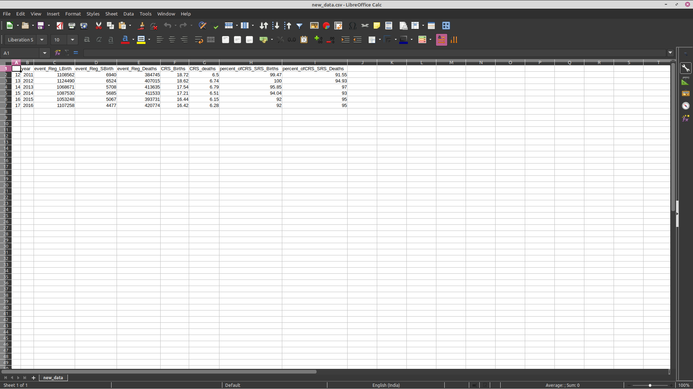
##################### Basic statistics for column 2 i.e, event_Reg_LBirth ################# min(nw_read[["event_Reg_SBirth"]]) max(nw_read[["event_Reg_SBirth"]]) mean(nw_read[["event_Reg_SBirth"]]) median(nw_read[["event_Reg_SBirth"]]) mode(nw_read[["event_Reg_SBirth"]]) var(nw_read[["event_Reg_SBirth"]]) sd(nw_read[["event_Reg_SBirth"]]) IQR(nw_read[["event_Reg_SBirth"]])
> min(nw_read[["event_Reg_LBirth"]])
[1] 1053248
> max(nw_read[["event_Reg_LBirth"]])
[1] 1124490
> mean(nw_read[["event_Reg_LBirth"]])
[1] 1091626
> median(nw_read[["event_Reg_LBirth"]])
[1] 1097394
> mode(nw_read[["event_Reg_LBirth"]])
[1] "numeric"
> var(nw_read[["event_Reg_LBirth"]])
[1] 725562028
> sd(nw_read[["event_Reg_LBirth"]])
[1] 26936.26
> IQR(nw_read[["event_Reg_LBirth"]])
[1] 34850.25
##################### Basic statistics for column 3 i.e, event_Reg_SBirth #################
min(nw_read[["event_Reg_SBirth"]]) max(nw_read[["event_Reg_SBirth"]]) mean(nw_read[["event_Reg_SBirth"]]) median(nw_read[["event_Reg_SBirth"]]) mode(nw_read[["event_Reg_SBirth"]]) var(nw_read[["event_Reg_SBirth"]]) sd(nw_read[["event_Reg_SBirth"]]) IQR(nw_read[["event_Reg_SBirth"]])
> min(nw_read[["event_Reg_SBirth"]])
[1] 4477
> max(nw_read[["event_Reg_SBirth"]])
[1] 6940
> mean(nw_read[["event_Reg_SBirth"]])
[1] 5733.5
> median(nw_read[["event_Reg_SBirth"]])
[1] 5696.5
> mode(nw_read[["event_Reg_SBirth"]])
[1] "numeric"
> var(nw_read[["event_Reg_SBirth"]])
[1] 821309.9
> sd(nw_read[["event_Reg_SBirth"]])
[1] 906.2615
> IQR(nw_read[["event_Reg_SBirth"]])
[1] 1098.5

##################### Basic statistics for column 4 i.e, event_Reg_Deaths #################
min(nw_read[["event_Reg_Deaths"]]) max(nw_read[["event_Reg_Deaths"]]) mean(nw_read[["event_Reg_Deaths"]]) median(nw_read[["event_Reg_Deaths"]]) mode(nw_read[["event_Reg_Deaths"]]) var(nw_read[["event_Reg_Deaths"]]) sd(nw_read[["event_Reg_Deaths"]]) IQR(nw_read[["event_Reg_Deaths"]])
> min(nw_read[["event_Reg_Deaths"]])
[1] 384745
> max(nw_read[["event_Reg_Deaths"]])
[1] 420774
> mean(nw_read[["event_Reg_Deaths"]])
[1] 405238.8
> median(nw_read[["event_Reg_Deaths"]])
[1] 409274
> mode(nw_read[["event_Reg_Deaths"]])
[1] "numeric"
> var(nw_read[["event_Reg_Deaths"]])
[1] 181407151
> sd(nw_read[["event_Reg_Deaths"]])
[1] 13468.75
> IQR(nw_read[["event_Reg_Deaths"]])
[1] 16057.5

##################### Basic statistics for column 5 i.e, CRS_Births #################
min(nw_read[["CRS_Births"]]) max(nw_read[["CRS_Births"]]) mean(nw_read[["CRS_Births"]]) median(nw_read[["CRS_Births"]])
mode(nw_read[["CRS_Births"]]) var(nw_read[["CRS_Births"]]) sd(nw_read[["CRS_Births"]]) IQR(nw_read[["CRS_Births"]])
> min(nw_read[["CRS_Births"]])
[1] 16.42
> max(nw_read[["CRS_Births"]])
[1] 18.72
> mean(nw_read[["CRS_Births"]])
[1] 17.49167
> median(nw_read[["CRS_Births"]])
[1] 17.375
> mode(nw_read[["CRS_Births"]])
[1] "numeric"
> var(nw_read[["CRS_Births"]])
[1] 1.023617
> sd(nw_read[["CRS_Births"]])
[1] 1.011739
> IQR(nw_read[["CRS_Births"]])
[1] 1.7175

##################### Basic statistics for column 6 i.e, CRS_deaths #################
min(nw_read[["CRS_deaths"]]) max(nw_read[["CRS_deaths"]]) mean(nw_read[["CRS_deaths"]]) median(nw_read[["CRS_deaths"]]) mode(nw_read[["CRS_deaths"]]) var(nw_read[["CRS_deaths"]]) sd(nw_read[["CRS_deaths"]]) IQR(nw_read[["CRS_deaths"]])
> min(nw_read[["CRS_deaths"]])
[1] 6.15
> max(nw_read[["CRS_deaths"]])
[1] 6.79
> mean(nw_read[["CRS_deaths"]])
[1] 6.495
> median(nw_read[["CRS_deaths"]])
[1] 6.505
> mode(nw_read[["CRS_deaths"]])
[1] "numeric"
> var(nw_read[["CRS_deaths"]])
[1] 0.06251
> sd(nw_read[["CRS_deaths"]])
[1] 0.25002
> IQR(nw_read[["CRS_deaths"]])
[1] 0.3475

############ Basic statistics for column 7 i.e, percent_ofCRS_SRS_Births ##########
min(nw_read[["percent_ofCRS_SRS_Births"]]) max(nw_read[["percent_ofCRS_SRS_Births"]]) mean(nw_read[["percent_ofCRS_SRS_Births"]]) median(nw_read[["percent_ofCRS_SRS_Births"]]) mode(nw_read[["percent_ofCRS_SRS_Births"]]) var(nw_read[["percent_ofCRS_SRS_Births"]]) sd(nw_read[["percent_ofCRS_SRS_Births"]]) IQR(nw_read[["percent_ofCRS_SRS_Births"]])
> min(nw_read[["percent_ofCRS_SRS_Births"]])
[1] 92
> max(nw_read[["percent_ofCRS_SRS_Births"]])
[1] 100
> mean(nw_read[["percent_ofCRS_SRS_Births"]])
[1] 95.56
> median(nw_read[["percent_ofCRS_SRS_Births"]])
[1] 94.945
> mode(nw_read[["percent_ofCRS_SRS_Births"]])
[1] "numeric"
> var(nw_read[["percent_ofCRS_SRS_Births"]])
[1] 12.54868
> sd(nw_read[["percent_ofCRS_SRS_Births"]])
[1] 3.542412
> IQR(nw_read[["percent_ofCRS_SRS_Births"]])
[1] 6.055

########### Basic statistics for column 8 i.e, percent_ofCRS_SRS_Deaths ##########
min(nw_read[["percent_ofCRS_SRS_Deaths"]]) max(nw_read[["percent_ofCRS_SRS_Deaths"]]) mean(nw_read[["percent_ofCRS_SRS_Deaths"]]) median(nw_read[["percent_ofCRS_SRS_Deaths"]]) mode(nw_read[["percent_ofCRS_SRS_Deaths"]]) var(nw_read[["percent_ofCRS_SRS_Deaths"]]) sd(nw_read[["percent_ofCRS_SRS_Deaths"]]) IQR(nw_read[["percent_ofCRS_SRS_Deaths"]])
> min(nw_read[["percent_ofCRS_SRS_Deaths"]])
[1] 91.55
> max(nw_read[["percent_ofCRS_SRS_Deaths"]])
[1] 97
> mean(nw_read[["percent_ofCRS_SRS_Deaths"]])
[1] 94.41333
> median(nw_read[["percent_ofCRS_SRS_Deaths"]])
[1] 94.965
> mode(nw_read[["percent_ofCRS_SRS_Deaths"]])
[1] "numeric"
> var(nw_read[["percent_ofCRS_SRS_Deaths"]])
[1] 3.568467
> sd(nw_read[["percent_ofCRS_SRS_Deaths"]])
[1] 1.889039
> IQR(nw_read[["percent_ofCRS_SRS_Deaths"]])
[1] 1.5175

############### PLOT 1: Line plot for number of vital event registered for various years ggplot(nw_read,aes(x = year,y = event_Reg_LBirth)) + geom_line(color = "red") + ggtitle("Number of vital events registered Live Birth VS Year")
######### DESCRIPTION OF PLOT 1: It can be clearly seen from the plot that in year 2012 highest number of vital event registered

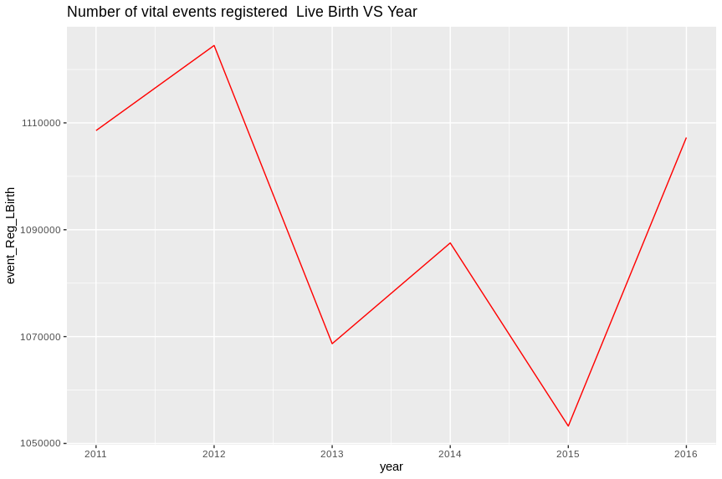

############### PLOT 2: Scatter plot for visualizing Death rates percentage of CRS vs SRS attach(nw_read)
plot(year, percent_ofCRS_SRS_Deaths, main="Scatterplot_year vs percent_ofCRS_SRS_Deaths ", xlab="year ", ylab="percent_of_CRS_SRS_Deaths ", pch=19) ############### DESCRIPTION OF PLOT 2: It can be clearly seen from the plot that in year 2013 highest percentage rate of CRS vs SRS registered
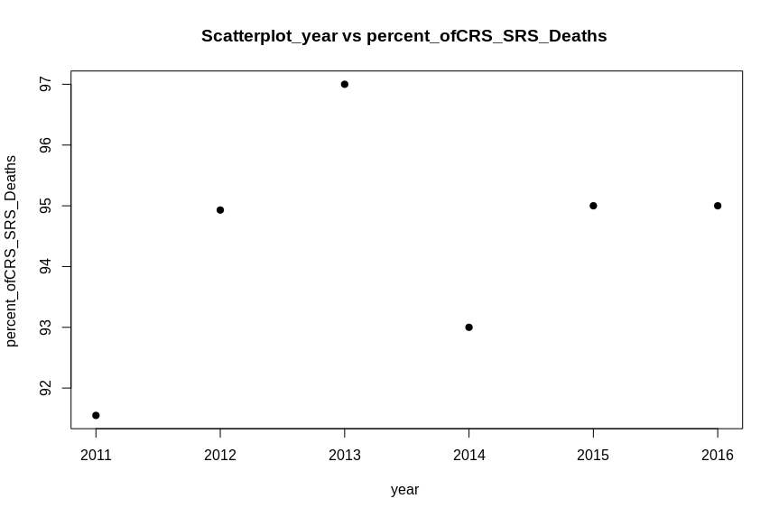
############# Reading the pdf file and Extracting districtwise aalysis for URBAN ##########
original_data <- "/home/dheeraj/Desktop/Lecture/6th_sem_Academics/DataScience/CRS_2016.pdf" # District_Urban <- extract_areas(original_data,pages = 16,output = "data.frame",header = F)
District_Urban District_Urban <- as.data.frame(District_Urban) colnames(District_Urban) <- c("Districts","Reg_birth","Birth_rate","Reg_death","Death_rate","Reg_infant_death","Reg_stil l_birth","Still_birth_rate") District_Urban write.csv(District_Urban, "/home/dheeraj/Desktop/Lecture/6th_sem_Academics/DataScience/district_urbn.csv", row.names = FALSE) dist_urban_read <- read.csv("/home/dheeraj/Desktop/Lecture/6th_sem_Academics/DataScience/district_urbn.csv") dist_urban_read
############### PLOT 3: Bar plot for visualizing registered death and birth for urban districts
Urban_analysis <- data.frame(District_Urban$Districts,District_Urban$Reg_birth,District_Urban$Reg_death) colnames(Urban_analysis) <- c("Districts","Reg_birth_in_the_districts","Reg_death_in_the_districts") Urban_analysis <- melt(Urban_analysis,id.vars = "Districts") ggplot(Urban_analysis,aes(x = Districts , y = value,fill = variable))+ylab("quantity") + geom_bar(stat = "identity",position = "dodge") + theme(axis.text.x = element_text(angle = 90, hjust = 1))
############### DESCRIPTION OF PLOT 3: By seeing the plot we can conclude that Banglore distrist have highest number of registered birth and death, and all the district have higher registered birth then death
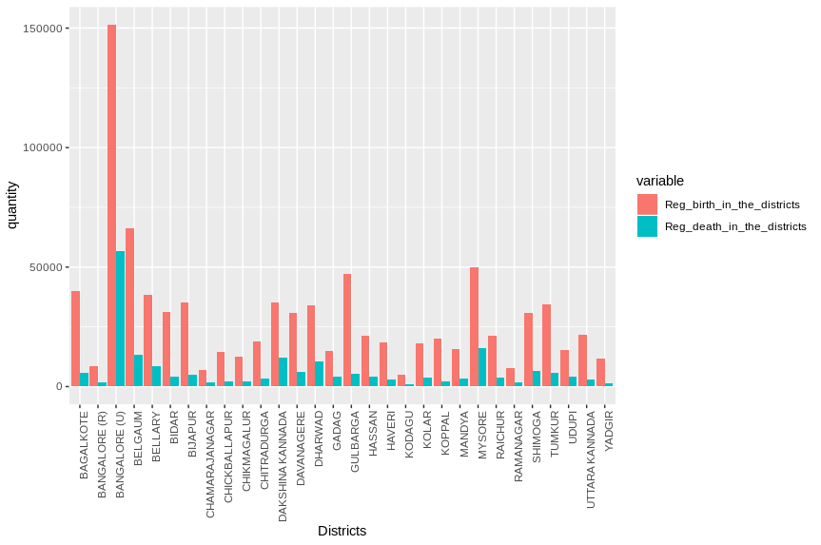
############### Reading the pdf file and Extracting districtwise aalysis for RURAL##################
original_data <- "/home/dheeraj/Desktop/Lecture/6th_sem_Academics/DataScience/CRS_2016.pdf" District_Rural <- extract_areas(original_data,pages = 17,output = "data.frame",header = F) District_Rural District_Rural <- as.data.frame(District_Rural) colnames(District_Rural) <- c("Districts","Birth_reg","Birth_rate","Death_reg","Death_rate","Reg_infant_death","Still_bi rth_reg","Still_birth_rate") District_Rural write.csv(District_Rural, "/home/dheeraj/Desktop/Lecture/6th_sem_Academics/DataScience/district_rural.csv", row.names = FALSE) dist_rural_read <- read.csv("/home/dheeraj/Desktop/Lecture/6th_sem_Academics/DataScience/district_rural.csv") dist_rural_read
############### PLOT 4: Box plot for visualizing registered infant death RuRAL District with OUTLIERS
boxplot(District_Rural$Reg_infant_death) num = as.numeric(District_Rural$Reg_infant_death) outvalues = boxplot(num)$out which(District_Rural$Reg_infant_death %in% outvalues)
############### DESCRIPTION OF PLOT 4: By seeing the plot we got the median as 27 that means 75 percent of district have registered infant deaths above 27 and 25% have below 27, and a dot is shown which is outlier
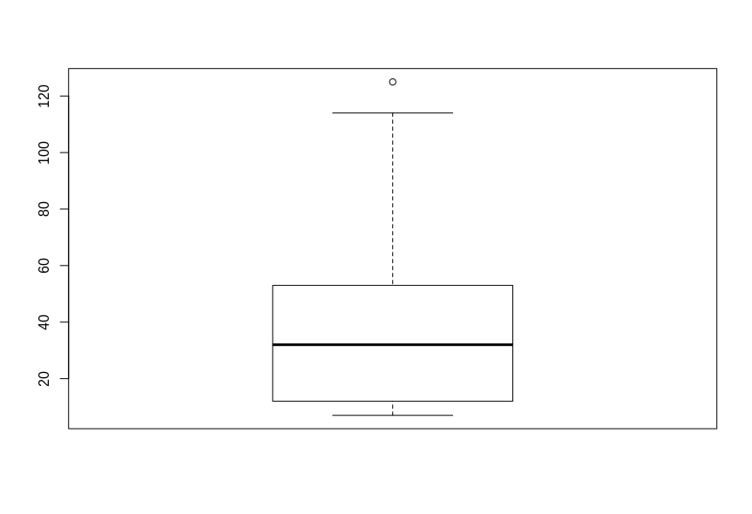

############### PLOT 5: Box plot for visualizing registered infant death RuRAL District without OUTLIERS removed = District_Rural$Reg_infant_death[!(District_Rural$Reg_infant_death %in% outvalues)] boxplot(removed)
############### DESCRIPTION OF PLOT 5: we can see that the outlier is removed and we are grtting the desired output
